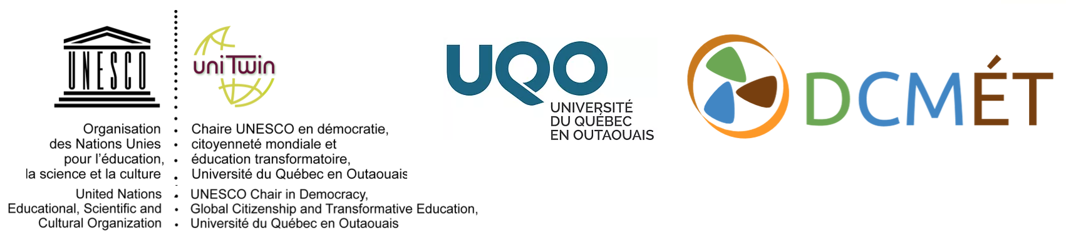
22 mars 2017

Greetings colleagues and friends,

RE: Formalization of the participation in the UNESCO Chair in Democracy, Global Citizenship and Transformative Education (DCMET) on the part of the members of the Executive Committee, the National Advisory Committee and the International Advisory Committee

We hope that everyone is doing well.

Quick update: The Members of the Executive Committee of the UNESCO Chair in DCMET have been meeting regularly since September 2016. Since then, significant progress has been made, including: the integration of the UNESCO Chair DCMÉT at UQO; start-up funding has been secured; a formal launch has been organized; external funding applications have been developed; a secretariat has been operationalized; partnerships have been developed; a full-day symposium in French has been organized to take place at ACFAS (McGill University, May 9, 2017).

As you already know, the official launch of our UNESCO Chair will take place on March 27 at UQO (Gatineau, Quebec, Canada). We hope that you attend this event but, if it is not possible for you, please know that it will be livestreamed on the Facebook page of the UNESCO Chair starting at 5:30 pm (Montreal time). https://www.facebook.com/UNESCO.CHAIR.DCMET/

Parallel to the formal launch, we are now formalizing the participation of the members of the three committees of the UNESCO Chair DCMÉT. To do so, we would kindly ask that you fill out the form below and return it to us as soon as possible via the Chair's e-mail (chaire.unesco@uqo.ca). More specifically, we would ask you to indicate: 1) your professional information for updating the website; 2) the possibility of your participation in a conference at UQO scheduled for the Fall of 2018; and 3) any other possible ideas or suggestions you may have for the Chair UNESCO.

- The Chair's website (http://uqo.ca/dcmet) will be launched on March 27 as well. It is trilingual (French, English, Spanish), it hosts a variety of resources related to the themes of the Chair, and is connected to several social media networks. We kindly ask you to provide us with information about your work to facilitate the updating of the site and networking among the members as well as your suggestions related to the content, links and ideas for improvement of the website!

2) We would like to organize a conference at UQO (Gatineau, Québec, Canada) in the Fall of 2018. To do so, we will apply for a Connection grant (SSHRC). We will be contacting you shortly on this matter, once we develop a concept note. If you think that might be able to take part, please let us know on the form.

3) We would appreciate it if you would provide us with any other forms of contribution to the UNESCO DCMÉT Chair that you might be able to make, including collaborative projects in research, training, partnerships, social dialogue, or invitations, or funding possibilities, etc..

Once again, we are extremely grateful to all those who have encouraged and supported us over the past few years. We sincerely hope that our collaboration will continue within the framework of the projects, events and activities of the UNESCO Chair DCMÉT!

All the best, in solidarity,

Paul R. Carr  Professeur & Titulaire / Professor & Chair-holder  Département des sciences de l'éducation  Université du Québec en Outaouais (UQO)  Gatineau, Québec, Canada | Gina Thésée  Professeure & Co-titulaire / Professor & Co-Chair  Faculté des sciences de l'éducation  Université du Québec à Montréal (UQAM)  Montréal, Québec, Canada
chaire.unesco@uqo.ca http://uqo.ca/dcmet
FORM FOR MEMBERS OF CHAIR COMMITTEES UNESCO DCMÉT *
Please return this completed form to the UNESCO Chair's e-mail address at chaire.unesco@uqo.ca

Professional information

Last name: ______________________________________ First Name: ________________________________
Position(s): _____________________________________________________________________________
Institutions: ___________________________________________________________________
E-mail: _______________________________________________________________________________
Web site: _____________________________________________________________________________
Facebook: ______________________________________________________________________________
Twitter: ________________________________________________________________________________

Names and contact information of any research center, institute, group or organization to which you are affiliated and which you would like to associate with the UNESCO Chair DCMET:

Keywords that best describe your domains of research and interests (5-7)

Describe briefly (150 words max.) an example of your involvement (training, research, publications, teaching, services, activities, etc.) in relation to any of the three themes of the UNESCO Chair DCMÉT: Democracy, Global Citizenship, Transformative Education

Publications or other achievements related to the three themes of the Chair or with associated topics

Indicate 3-4 of your publications or other accomplishments related to the three thematic axes of the Chair (Democracy, Global Citizenship and Transformative Education). Include full reference as well as links, images or other relevant information, if possible, for filing on the site.

Title: _________________________________________________________________________________
Author(s): ______________________________________________________________________
Year of publication: ________________
Journal, book, issue number, other: _____________________________________________________

Title: _________________________________________________________________________________
Author(s): ______________________________________________________________________
Year of publication: ________________
Journal, book, issue number, other: _____________________________________________________

Title: _________________________________________________________________________________
Author(s): ______________________________________________________________________
Year of publication: ________________
Journal, book, issue number, other: _____________________________________________________

Title: _________________________________________________________________________________
Author(s): ______________________________________________________________________
Year of publication: ________________
Journal, book, issue number, other: _____________________________________________________

Academic meeting of the UNESCO Chair DCMÉT
Would you be interested in participating to a conference organized by the UNESCO Chair DCMÉT that will be held in Gatineau (Québec, Canada) in Fall 2018? Yes______ / No_____ / Maybe_______

Do you have any comments or suggestions related to such an event?

Would you be willing to take part in organizing the event (human resources, funding, organizing committee, scientific committee, etc.)? And, if so, how?

Other comments or suggestions to share?

* N.B. Some of the information provided may be used on the UNESCO Chair DCMET website or in other materials.

